Week 2:

Task 1: Write 1-2 sentences reflections of what is responsive web design and why it is important?

In essence, responsive design is a method of creating a website that automatically adapts its information and elements to fit the screen size on which it is viewed. It stops graphics from being larger than the screen width and saves mobile visitors from having to do extra work to understand your material. The technique combines flexible grids and layouts, graphics, and the judicious use of CSS media queries. The primary advantage of responsive web design is that pages load quickly and without distortions, eliminating the need for users to manually resize anything to read content.

Task 2: Capture screenshots and write 1-2 sentences reflections about how to implement responsive web design with CSS

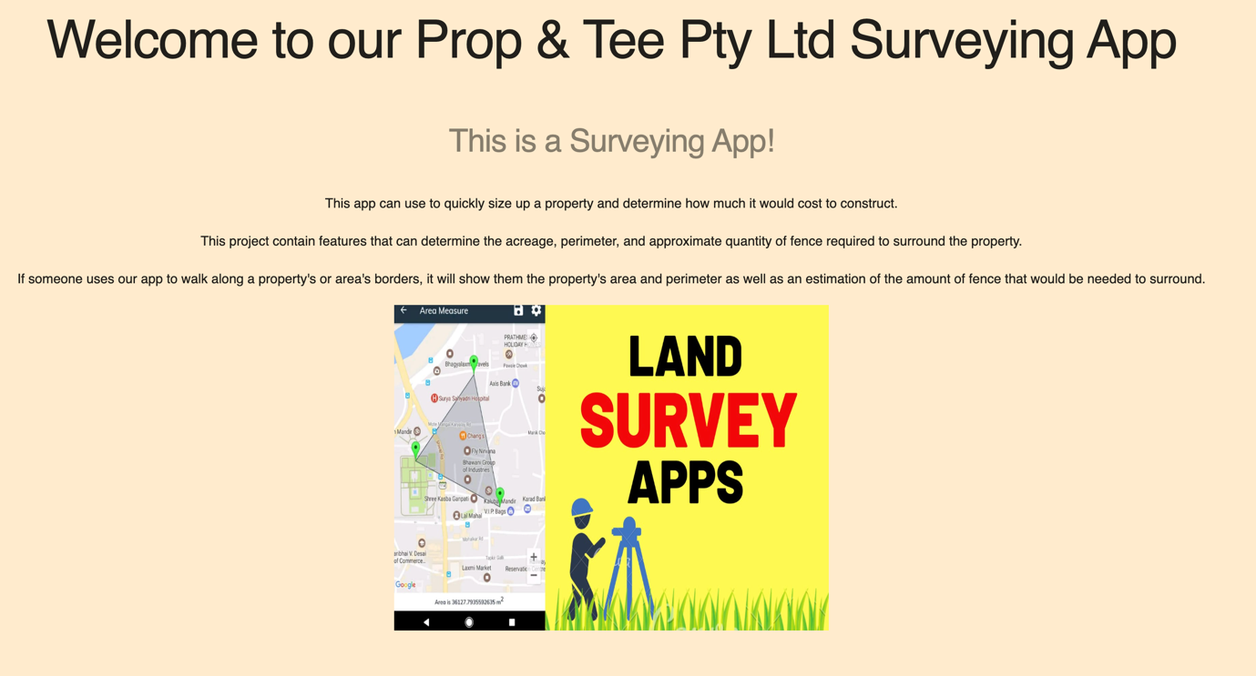

In order to implement a responsive web app the first thing is to set a viewpoint to the page which will give the browser instructions on how to control the page's dimensions and scaling.

Code: <meta name="viewport" content="width=device-width, initial-scale=1.0">

Task 3: Write 2 user stories for web page functions e.g., login function, produce a Figma demo (1 ~ 2 pages). Write 1-2 sentences reflections about why user stories and UI/UX prototype is important in responsive web design?

These 2 User Stories are according to my project:

1. As a user, I should know what the website is about so that I have a clear idea how it works and its purpose.
2. As a user, I should not face any issue during the process it should function properly as programmed.

User Stories are the process of boosting the interactivity and presentation of a mobile app or website. Its design is user-friendly, with easy navigation and straightforward direction, allowing your visitors to go exactly where they need to go. Furthermore, the process leads to the aim of your website is clear and straightforward.

Task 4: Develop one page including Canvas (example a line), video tag, audio tag and embed a YouTube video. Capture screenshots and write 1-2 sentences on the utility of these elements while designing a responsive web app?

If any of these elements are being used to design a responsive web app, it is for sure the attraction of the user is pretty and high and it allows the users to focus more into the important content of the page.

For instance for my project I am looking forward to add map using API which will look similar to the screenshot below.

